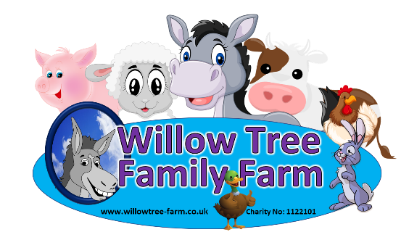

School Booking Form
PLEASE CHECK AVAILIBILITY BEFORE SENDING THE FORM TO AVOID DISSAPOINTMENT.
Please complete this booking form and email to david.anthony@willowtree-farm.co.uk.
Please note we cannot take provisional bookings.
YOUR BOOKING WILL BE SECURED ONCE WE RECEIVE THE BOOKING FORM. Once received, a full invoice will be sent for the numbers stated on the form. Cancellations or amendments within 28 days of your visit will be charged in full.
ALL PAYMENTS MUST BE PAID FOR IN FULL PRIOR TO YOUR VISIT.
WE RESERVE THE RIGHT TO REFUSE ADMISSION IF PAYMENT IS NOT RECEIVED BY ARRIVAL.
If you are paying by BACS this needs to have CLEARED 5 working days before your visit.
Annual Passes and Corporate cannot be used in conjunction with our school packages.
Date of visit |  | Type | Nursery |  |  | Primary |  | Secondary
Name of Organizer |  | (Please Tick) | Vocational |  |  | S.E.N. |  | Other
Name of Group
Address
 |  |  | Postcode
School Office Email Address |  |  | Contact No
Invoice Email Address |  |  | Age of Children
No. of Children |  |  | Arrival Time
No. of Adults |  |  | Departure Time

EDUCATION PACKAGES  (Please Tick)  Each package includes 1 free adult per 5 paying children | £7.95 per child  farm Visit only |  | Education Sessions  (Please Tick)  All Education Sessions last 45-60 minutes Max of 30 per group | Farm only
 | £8.20 per child  Entry, farm tour (1 talk) |  |  | Reptiles, meerkats ,exotics
 | £9.50 per child  Entry , farm tour , ice cream |  |  | Farm , Reptiles, meerkats ,exotics
 |  |  |  | Please ticket what your interested in

How did you hear about us?
Lunch: We will reserve a designated indoor area for your group upon receiving the booking form.
Drinks and snacks are also available to purchase from the Café.
The Café is able to cater for all requirements however we will need prior notice.
Please return this form to: Email: david.anthony@willowtree-farm.co.uk Telephone: 01623-748808 / 07798895093

Website: www.willowtree-farm.co.uk

Please tick to confirm terms and conditions sheet have been read and agreed Signature______________________________________ Signature: __________________________________

